An educational institute (school) wanted to automate the computation of LMS (Learning management system) quiz attempts by students. The manual processing of quizzes results every week by unit coordinator is not effective. You are tasked to design, test and implement the algorithm to work out the reports after every week for a particular course unit.

The number of students in the unit may varied from a hundred to a few thousands when it is open for public enrolment. The first student’s ID is always 10001.

A quiz will be conducted at the end every lesson, the students are allowed to attempt the quiz as many times as they wish.

The quiz will be downloaded as a csv files named with <unitCode>Quiz<??>.csv and stored in the Quiz folder:

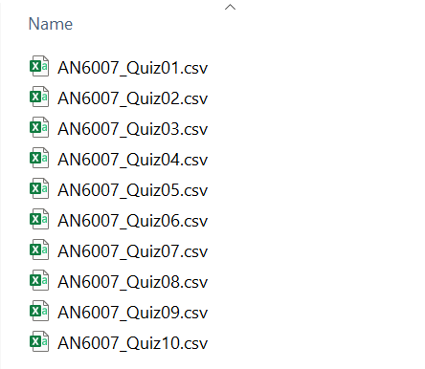

Each of the file will contain data of the class of the student, the student ID and the student’s score for that quiz.

The school has intended to perform the following analysis :

1. Quiz performance analysis – Attempts & Passing Rate

1. Quiz performance analysis – mark distribution on quizes

1. Class performance analysis : Class upper score analysis

1. Class performance analysis : Pass/Fail rate

1. Student performance analysis : Student Individual Quiz Analysis

(for illustration only, incomplete)

1. Student performance analysis : Students Quiz performance analysis.

(for illustration only, incomplete)